Nevada Department of Employment, Training and Rehabilitation Employment Security Division
Workforce Programs

Workforce Innovation and Opportunity Act (WIOA) State Compliance Policy (SCP)

Policy Number: 5.2
Originating Office: Department of Employment, Training and Rehabilitation (DETR); Workforce Programs

Subject: Forms for Reporting Fraud and Abuse
Approved: Governor’s Workforce Development Board (GWDB) Executive Committee July 17, 2024; NEW May 2019 replacing Workforce Investment Act (WIA) Section 5.2. Approved GWDB Executive Committee June 20, 2019; Ratified GWDB July 16, 2019
Purpose: To transmit procedures to be used by all Employment and Training Administration (ETA) grant recipients for reporting allegations of fraud, program abuse or criminal conduct involving grantees or other entities and subrecipients receiving Federal funds either directly or indirectly from ETA.

State Imposed Requirements: This directive may contain some state-imposed requirements. These requirements are printed in bold, italicized type.
Authorities/References: Workforce Innovation and Opportunity Act (P.L. 113-128), TEGL 15-23, Nevada SCPs
ACTION REQUIRED: Upon issuance bring this guidance to the attention of all WIOA service providers, Local Workforce Development Board (LWDB) members and any other concerned parties. Any LWDBs policies, procedures, and or contracts affected by this guidance are required to be updated accordingly.

Background: The Code of Federal Regulation (CFR) requires sub-recipients to report allegations, suspicions, and complaints of possible fraud, program abuse and criminal activities involving WIOA Title I-B funds. The detection and prevention of fraud and abuse in programs authorized by the Department of Labor (DOL) are of the highest priority. Therefore, systematic procedures for reporting instances of suspected or actual fraud, abuse or criminal conduct are vital. States, local governments and grantees may become aware of actual, potential or suspected fraud; gross mismanagement or misuse or program funds; conduct violations; violations of regulations; and abuse.

This policy provides the Office of Inspector General (OIG) contact information, Hotline telephone number and reporting forms and their proper use.

Grant recipients must be familiar with Incident Reporting Requirements in SCP 4.7, TEGL 15-23 and follow the procedures set forth herein for documenting, immediately reporting to the State (Workforce Programs)/OIG, and following-up on instances of alleged, suspected or known fraud, program abuse and criminal misconduct involving grantees and other recipients, including Eligible Training Providers and subrecipients of Federal funds from ETA.

Responsibilities: Grant recipients are responsible for following the procedures set forth in this policy and SCP 4.7 as required by TEGL 15-23. Grant recipients must immediately document allegations, suspicions and complaints involving possible fraud, program abuse and criminal misconduct using the IR form and instructions contained in this link.

Additionally, situations involving imminent health or safety concerns, or the imminent loss of funds exceeding an amount larger than $50,000, are considered emergencies and must immediately be reported to the OIG and [Office of Financial and Administrative Management] (OFAM) and Workforce Programs by telephone and followed up with a written report in the form of an IR, no later than one working day after the telephone report.

DETR/Workforce Programs, acting on behalf of the Governor, is responsible for submitting the IR to OIG upon receipt and clarification of information of an alleged incident and as appropriate.

Hotline Referrals:
In addition to the ETA process set forth in TEGL 15-23, the OIG operates the Hotline Portal to receive and process allegations of fraud, waste, and abuse concerning Departmental grants, contracts, programs and operations. The OIG Hotline Portal is also used to address allegations of criminal activity and serious misconduct involving Department employees. Incident reports should be submitted online at: https://www.oig.dol.gov/hotline.htm.

When contacting OIG Hotline, provide as much detailed information as possible concerning the allegations, including:
- Who is involved;
- When the situation you are reporting took place and whether it is still ongoing;
- Where the situation occurred;
- What happened that was inappropriate and prompted you to contact the OIG Hotline;
- How the situation took place.

OIG Hotline Portal Contact Information
Hotline complaints can be sent directly to the Complaints Analysis Office, Office of Inspector General, 200 Constitution Avenue, N.W., Room S-5506, Washington, D.C. 20210. They can be telephoned to the OIG on the Toll-Free Hotline at 1-800-347-3756 or (202) 693-6999 (this is not a toll-free number); or they can be emailed to hotline@oig.dol.gov. The OIG Hotline should not be used for resolving employee grievances, Equal Employment Opportunity complaints, labor disputes, or other personnel concerns.

https://www.oig.dol.gov/ https://www.oig.dol.gov/hotlineform.htm
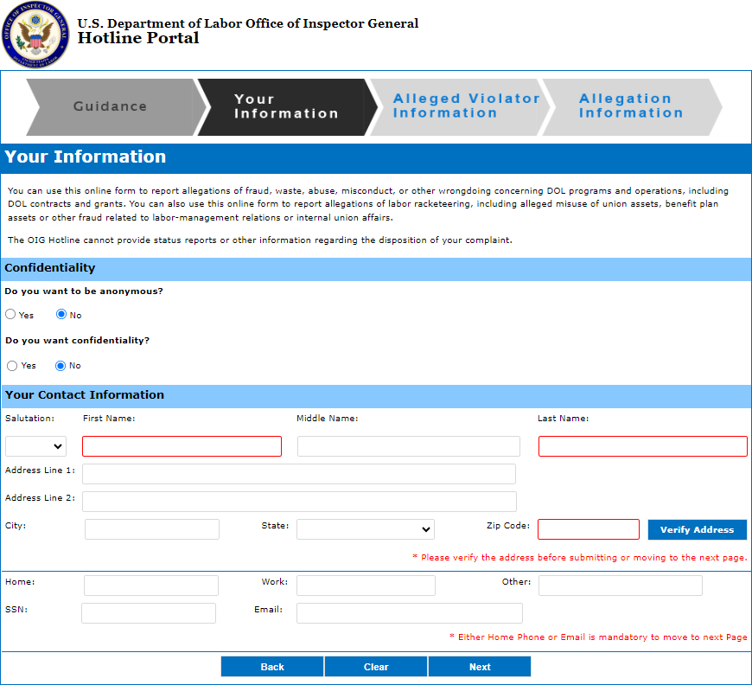

If your complaint involves any of the topics listed below, please DO NOT use this form, but follow the instructions provided.
For pay-related complaints or Family and Medical Leave Act issues contact the Wage and Hour Division at 1-866-4USWAGE (1-866-487-9243) or at http://webapps.dol.gov/contactwhd/default.aspx
For concerns or complaints regarding individual pension, health, or other employee benefits, including COBRA coverage issues, contact the Employee Benefits Security Administration at 1-866- 444-3272 or at http://www.askebsa.dol.gov/WebIntake/Home.aspx

If you are a current or former federal employee and have concerns about your workers' compensation claim, see http://www.dol.gov/owcp/owcpkeyp.htm for specific contact information.

If you have concerns involving a workers' compensation claim and you are NOT a current or former federal employee, contact your state compensation board.

For workplace safety and health issues, contact the Occupational Safety and Health Administration (OSHA) at 1-800-321-OSHA (6742) or at https://www.osha.gov/pls/osha7/eComplaintForm.html

To file a complaint under a whistleblower statute enforced by OSHA go to: https://www.osha.gov/whistleblower/WBComplaint.html

To report mining safety and health issues, contact the Mine Safety and Health Administration at1-800- 746-1553.

To report union representation issues or allegations of unfair labor practices by management and/or union officials, contact the National Labor Relations Board at 1-866-667-6572.

To file a workplace discrimination or sexual harassment complaint, contact the U.S. Equal Employment Opportunity Commission at 1-800-669-4000.

If you believe that a claim for unemployment benefits has been unfairly denied, contact your state's unemployment compensation office.

For all other general DOL-related inquires that do not involve fraud, waste or abuse in DOL programs, or misconduct by DOL employees, contractors, or grantees, contact the U.S. Department of Labor National Contact Center at 1-866-4-USA-DOL (1-866-487-2365).

To report a fraud, waste, and abuse complaint involving another Federal agency besides DOL, see https://www.ignet.gov/content/inspectors-general-directory for contact information for all Federal Inspectors General.

