Nevada Department of Employment, Training and Rehabilitation Employment Security Division
Workforce Programs

Workforce Innovation and Opportunity Act (WIOA) State Compliance Policy (SCP)
Policy Number: 3.10

Originating Office: Department of Employment, Training and Rehabilitation (DETR); Workforce Programs

Subject: Program Income

Approved: Governor’s Workforce Development Board Executive Committee May 15, 2024; Replacing July 2005 Workforce Investment Act (WIA)

Purpose: Provide guidance on income generated with the use of funds awarded through programs by DETR.

State Imposed Requirements: This directive does not contain state-imposed requirements. These requirements are printed in bold, italicized type.
Authorities/References: WIOA Sec. 194 (7) (A)-(C), 20 CFR § 683.200 (c)(9), 2 CFR §§ 200.80,
200.307, 200.311, 200.314, and 200.344, TEGL 28-10, TEGL 15-14, DOL/ ETA-9130 Financial
Reporting Resources and ETA-9130 Forms and Instructions.

ACTION REQUIRED: Upon issuance bring this guidance to the attention of all WIOA service providers, LWDB board members and any other concerned parties. Any local boards’ policies, procedures, and or contracts affected by this guidance are required to be updated accordingly.
Background: The Uniform Administrative Guidance (UG), in conjunction with the Workforce Innovation and Opportunity Act (WIOA) and its regulations, provide specific guidance regarding what constitutes program income and how it is to be handled.
Policy and Procedure:
Program Income
Program Income per 2 CFR § 200.80 means, “gross income earned by the non-Federal entity that is directly generated by a supported activity or earned as a result of the Federal award during the period of performance except as provided in § 200.307 paragraph (f).”
Paragraph (f) states, “There are no Federal requirements governing the disposition of income earned

after the end of the period of performance for the Federal award, unless the Federal awarding agency regulations or the terms and conditions of the Federal award provide otherwise. The Federal awarding agency may negotiate agreements with recipients regarding appropriate uses of income earned after the period of performance as part of the grant closeout process.”
Information on what is and is not considered program income can be found in 2 CFR § 200.80, as well as individual agency guidelines. Program income may include:
- Fees for services performed during the period of performance.
- Use or rental of real or personal property acquired under federal awards.
- License fees and royalties on patents and copyrights.
- Sale of commodities or items fabricated under a federal award (e.g., publications).
- Payments of principal and interest on loans made with federal awards.
Per 2 CFR § 200.80, program income may not be interest earned on advances of federal funds, and program income does not include rebates, credits, discounts, and interest earned on any of them, unless specific agency regulations or the grant agreement indicates otherwise. Generally, taxes, special assessments, levies, fines, and other such revenues are not program income, unless they are specifically defined in the grant agreement or agency regulations. These types of income are frequently mentioned in agency guidelines, so grantees and subrecipients should be careful that these revenue sources are properly reported and applied.
Note: If authorized by agency regulations or grant agreement terms and conditions, costs incidental to generating program income may be deducted from gross income to determine program income, provided these costs have not been charged to the grant. AND Grantees generally do not have any obligation to the federal government regarding program income earned after the end of the project period, as indicated in paragraph (f) of 2 CFR § 200.80, cited above.

NOTE: Different fund sources use different methods of calculating program income. WIOA subrecipients must use the addition method. Funding may be braided with other sources that must use the other methods shown below. Per the ETA-9130, the Addition Method is required for all ETA programs/grants. Refer to your to your subaward and applicable regulations to ensure the proper methodology is applied.
Three Ways Program Income may be Applied
There are three ways in which program income can be applied: deduction, addition, and cost sharing or matching. These three methods for applying program income are further explained below.
Most types of recipients, absent more specific guidance from the DOJ grant-making component, must use program income to offset total allowable costs, and reduce the Federal award and non- Federal entity contributions (i.e., the deduction method). Institutions of Higher Education (IHE) and non-profit research institutions, absent more specific guidance, may use program income to add to the total allowable costs for the project (i.e., the addition method, as required for all ETA programs/grants).

Method 1: Deduction
The default method for how grantees apply program income is deduction—deducting the income from the grant’s total allowable costs. In the example shown below, in figure 1, if $80,000 for a cost was designated to the federal share of grant funds and $20,000 to the grantee’s share of grant funds, the total project cost would be $100,000. If the grantee earned $10,000 of income related to that funded program, $8,000 would be returned to the awarding agency, while $2,000 goes to the grantee.
Figure 1: Deduction of Program Income

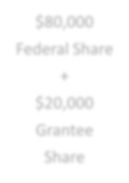




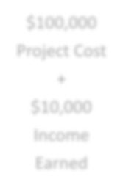






$80,000
Federal Share
+
$20,000
Grantee Share
$100,000
Project Cost
+
$10,000
Income Earned
$8,000
to Federal Agency
$2,000
to Grantee

Method 2: Addition

A second method for handling program income is addition—meaning that program income can be added to the federal award. Other nonfederal entities may use the additive method with prior approval from the federal awarding agency. Similar to the project in figure 1, the project in figure 2 is funded 80% by the federal share and 20% by the grantee share and the total project cost is
$100,000. In this case, though, when the grantee is using the addition method of handling program income, the $10,000 of program income is added to the $100,000 of initial project funding, so that now $110,000 is available for the project.

Figure 2: Addition of Program Income


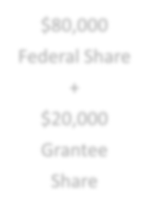




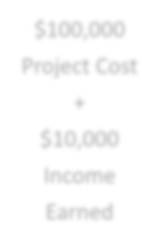






$80,000
Federal Share
+
$20,000
Grantee Share
$100,000
Project Cost
+
$10,000
Income Earned
$110,000
Available
for Project Cost

Method 3: Cost Sharing or Matching

A third method for handling program income is to apply it to meet the nonfederal cost sharing or matching requirement of the grant. This alternative can be used if allowed by the agency regulations and specific grant agreement. Again, as in figures 1 and 2, the project is jointly funded by the federal awarding agency at $80,000 and the grantee at $20,000. With a cost sharing or matching approach, the income earned of $10,000 reduces the grantee share from $20,000 to $10,000.

Figure 3: Cost Sharing or Matching with Program Income

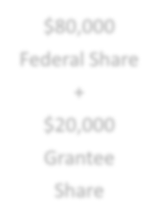




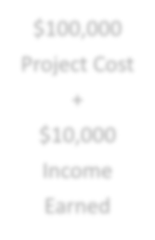



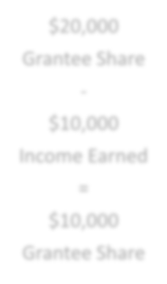

$80,000
Federal Share
+
$20,000
Grantee Share

$100,000
Project Cost
+
$10,000
Income Earned
$20,000
Grantee Share
-
$10,000
Income Earned
=
$10,000
Grantee Share

Figures 1-3 for reference material only.

